

Software Project CA1

By Jonathan Berkeley and Eoin Barry



Contents:

Section 1 - Concepts and execution: 2

Section 2 - Creating the game: 4

Section 2 - Innovation: 7

Section 4 - References and Credits: 8

# Section 1 - Concepts and execution:

Our game is called “Attack of the Sprites”. The aim is to kill all the stormtroopers on a level to progress to the next and accumulate score. You have limited ammo and you can ricochet your shot off walls and obstacles to hit the stormtroopers. The game is Star Wars themed and the projectile you shoot is a laser.

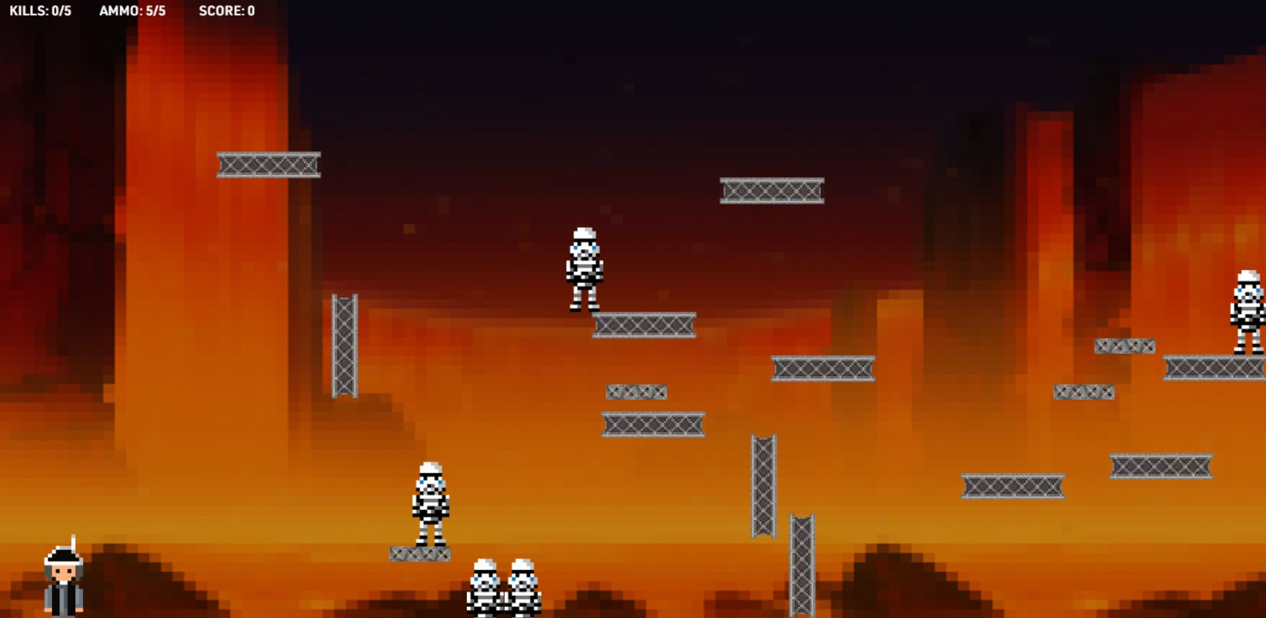

Figure 1

The game was inspired by ‘Ricochet Kills’, an online game where you have limited ammo and can ricochet your bullet. That game is mafia themed and we have implemented numerous features that separates our game from Ricochet Kills.

Our original game concept was quite different than the end product. We removed and added gameplay features as we went along to adapt to the timeline we were given and our limited knowledge of phaser. one of the original ideas we cut was the shop where the player could spend their score on upgrades such as more ammunition. One features we added that wasn’t in the game design document was randomly generated levels and enemy placement.

The randomly generated levels and enemy placement became maybe the best part of our game as it allows for much greater replay value. You can play again and again to try and beat your high score and never face the same level twice.

Another great aspect of the game is the score system. You are rewarded extra points for killing multiple stormtroopers with one shot, for ricocheting the bullet of multiple surfaces before getting a kill, and a great deal of points for wiping out all the stormtroopers with your first shot. This makes the game more methodical and fun if you are trying to beat your high score.

We added randomized sound effects for when the laser ricochets off a surface or for when a stormtrooper is killed. The game also selects from 3 8-bit Star Wars tracks when it plays. The buttons on the menus also play a Star Wars sound when clicked.

Other details went into making the Star Wars theme engaging such as the title menu background, the Star Wars title text on the menus and the custom font downloaded which was converted to multiple different font file formats for compatibility with other browsers. The game also selects from 3 backgrounds every time a new level starts. The backgrounds are Tattoine, Hoth and Mustafaar.

# Section 2 - Creating the game:

The project management was quite smooth during the whole process. Jonathan was better at coding and Eoin was better at photoshop and using Piskel so at the start, Eoin supplied the assets and Jonathan put them in the game and we made fast progress.

On the title screen, we made the starry background a sprite so we could manipulate it later. In the update section, we then made it move to the left on a loop. We then made buttons with a hover feature where they change colour. They also play a sound when clicked.

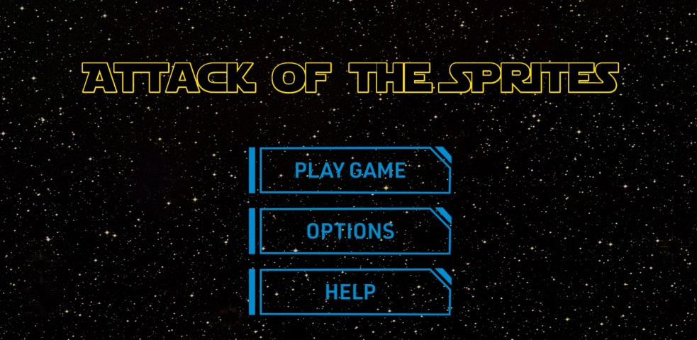

Figure 2

In our options menu, we have a mute button and aim assist button that are toggleable.

In the help menu, we have text explaining the aim of the game and how to play.

As we stated above in the innovations section, the bounce collision checking was the most difficult part of the project and was done independently of arcade physics. Code shown below:

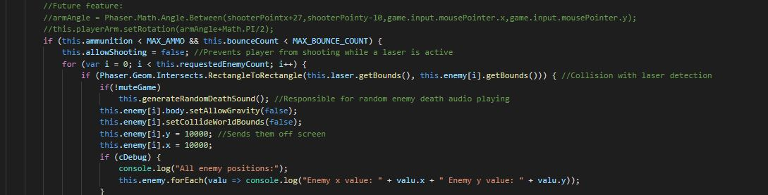

Figure 3

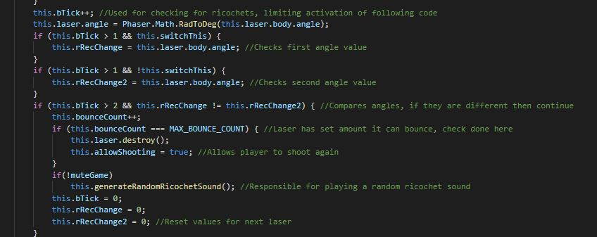

Figure 4

We added multiple sound possibilities. A random number generator adds diversity to the game and keeps it engaging. This takes effect on the laser ricochet sounds and the stormtrooper death sounds.

We randomly generate enemies and platforms for our endless levels to always be unique and have variety. Some code shown below:



Figure 5

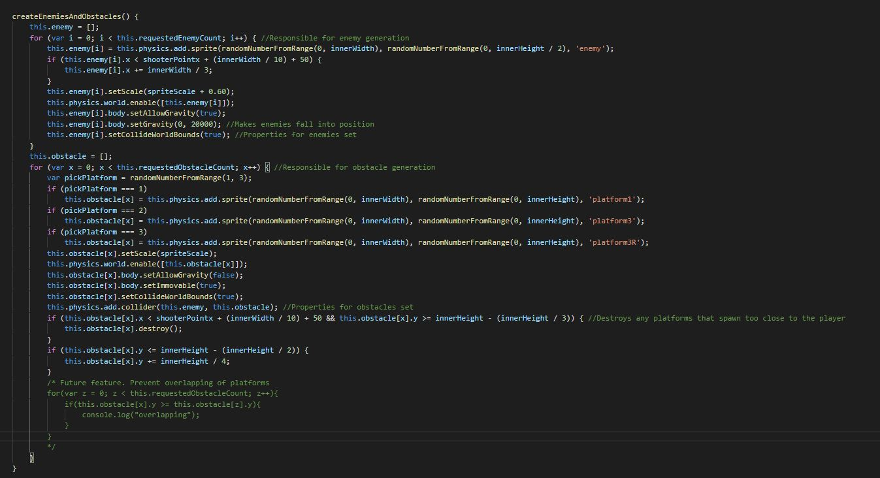

Figure 6

We also have a Game Over scene telling the player that they ran out of ammo (The only way to lose) and showing the player the score they accumulated and their high score.

One other small detail we added was our Favicon. Shown below:



Figure 7

# Section 2 - Innovation:

The biggest innovation that sets our game apart from Ricochet Kills is the randomized level generation and enemy placement which allows for an infinite amount of level combinations and greatly increases replay value.

Another innovation is the bounce collision which was done independently of the arcade physics in Phaser and was no doubt the hardest part of the whole project.

One other noticeable innovation is the tickrate. The tickrate is a variable that increases by 1 every time the update scene is run. This feature was crucial for our game in the end for timing actions with each other and fixing bugs (E.G. When the game is started, the player cannot shoot until 41 ticks have passed which prevents accidental weapon firing).

A last innovation we added is the dynamic resizing. To compensate for different screen sizes, dynamic resizing allows the game to be playable in full screen on a large variety of screen sizes.

(Sprites and images resize to match screen size. The placement for sprites never uses fixed values, instead they use calculations based on screen size.)

# Section 4 - References and Credits:

Creating Sprites - <https://www.piskelapp.com/>

Phaser tutorials - <https://phaser.io/learn/community-tutorials>

Music - <https://www.youtube.com/watch?v=FvG4ZjHbkLg>

<https://www.youtube.com/channel/UCn4HDI02U4f3VEsghRX7dRw>

Logos - <https://fontmeme.com/star-wars-font/>

Font - <https://arabicfonts.net/fonts/urw-din-arabic-demi?fbclid=IwAR2oR3IAFMDDcTD1yGe32un2Qkn3Iezbj3WyQdA_hGXTvD6aF4gHvNBumXs>